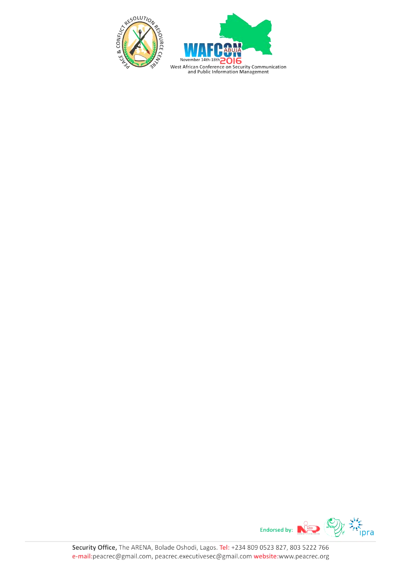
Bart De Vries
President
International Public Relations Association (IPRA)
Dear Sir,
LETTER OF APPRECIATION
On behalf of Peace and Conflict Resolution Resource Centre (PEACrEc) and the entire WAFCON Team members, we thank you for attending/participating at the West African Conference on Security Communication and Public Information Management held on January 23rd - 27th, 2017 at the Nicon Luxury Hotel, Abuja, Nigeria.
We hope that you found the conference informative and worthwhile.
We believe that our diverse and dynamic group of speakers and panelists provided in-depth insight, as well as, actionable and practical techniques that have worked in other regions.
Your endorsement and contribution helped to make this event a great success and your enthusiasm and positive spirit helped made our time together both productive and fun. We wish you all the best and hope that you continue to be engaged with WAFCON’s next year’s edition. You can visit our website for upcoming conference by visiting www.wafcon.com.
To make our next year’s conference even more successful we humbly request that you fill out a post-event survey found at www.wafcon.com/survey.
Thank you in advance for your comments and suggestions and we assure you that each will be given consideration so that future conferences and events will be better.
If you wish to view photos from the event please visit @peacrec (Peace and Conflict) on Facebook or visit the conference webpage www.wafcon.com.
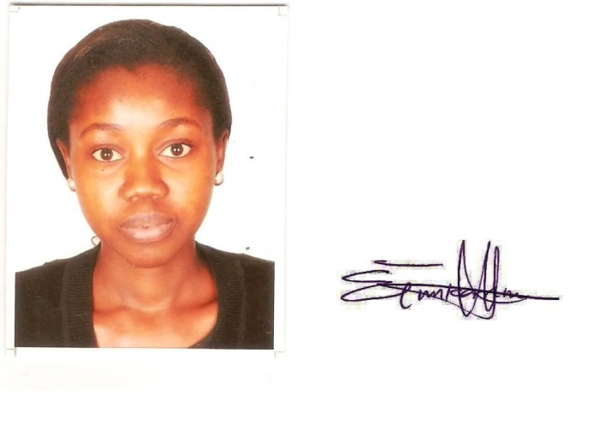
Taiwo Tenny Tunkarimu
Project Executive
FOR: WAFCON2017

