June 2, 2016

Bart de Vries
President
International Public Relations Association (IPRA)
Suite 5879
POB 6945
London W1A 6US

Dear Sir,

Letter of Appreciation

On behalf of the Executive Council of the African Public Relations Association (APRA), I wish to express our profound appreciation to you and your organization for your kind support towards the successful hosting of the 28th African Public Relations Association’s Conference held at the Calabar International Convention Centre (CICC), Cross River State, Nigeria from May 24-27, 2016.

Your presentation at the conference was quite insightful and I believe this will impact positively on public relations practice across the continent going forward.

Kindly see http://bit.ly/1TOwYSB for yours and other papers presented at the conference.

Once again, please accept our warm regards.

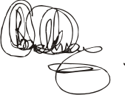
Yomi Badejo-Okusanya
President

