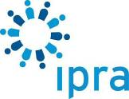



IPRA GWA 2018 Entry Kit
This entry kit is a set of complete instructions on how to enter the world’s most prestigious public relations awards scheme.

The annual IPRA Golden World Awards (GWA) initiative, established in 1990, recognizes excellence in public relations practice worldwide in a variety of categories. Recipients of the award take particular pride in the recognition granted to their entry as meeting international standards of excellence in public relations. An overall IPRA Grand Prix for Excellence is presented each year to the entry judged as representing the highest standards that year. While there are many national and regional PR awards, there is only one truly global scheme: the GWA.

Contents

1. Background to the GWA 2
2. 2018 Dates and Deadlines 2
3. 2018 Fees 2
4. Frequently Asked Questions 3
5. Entry Template 6
6. GWA Categories 7
7. The Rules 10

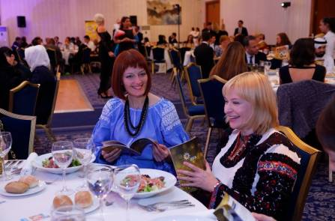 | 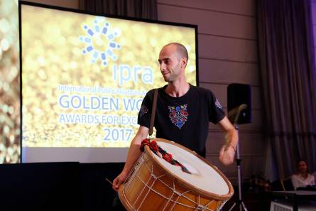 | 

1. Background to the GWA

What are the GWAs?
IPRA’s Golden World Awards for Excellence in Public Relations, established in 1990, celebrates each year the outstanding achievements of global communication professionals. The annual GWAs also bring together the profession and its practitioners and offer a platform for collegial exchange and learning.

Who is the organization behind it?
IPRA, the International Public Relations Association, is the leading global network for public relations professionals. Membership is individual not corporate. It aims to further the development of open communication and the ethical practice of public relations. IPRA fulfils this aim through networking opportunities, its code of conduct, and intellectual leadership of the profession. With 60 years of experience, IPRA, recognised by the United Nations, is now present throughout the world wherever public relations are practiced. IPRA welcomes all those within the profession who share its aim and who wish to be part of the IPRA worldwide fellowship. Through its networks, IPRA represents over 12,000 communications professionals around the world.

2. 2018 Dates and Deadlines
Entries open Tuesday 27 February 2018.
Entries close Monday 21 May 2018.

Any entry received after 21 May 2018 is ineligible.

3. 2018 Fees
The basic fee is £360 per entry. There is a discount for early-bird entries and a penalty for late entries.

Early (Tuesday 27 February – Monday 26 March 2018) £330
Normal (Tuesday 27 March – Monday 23 April 2018) £360
Late (Tuesday 24 April – Monday 21 May 2018) £400

4. Frequently Asked Questions

1. Who can apply for the GWA?
The GWA is open to all communication professionals, from such diverse fields as public relations, corporate and internal communications, brand building, and reputation management. Companies, consultancies, associations, institutions, and NGOs can apply. IPRA encourages entries from universities and educational institutions.

2. What are the entry requirements and qualifying dates for entries?
Entries must be submitted to IPRA online. Entries must be for PR programmes that "completed" before the start date of the annual competition. The programmes may have started one or more years before this. By "completed" we mean that you must have enough information to be able to answer section 6 "Outcome and Evaluation".

3. How many categories may I apply for?
Any organisation may submit an unlimited number of entries. Each entry attracts a unique entry fee.

4. Can I submit the same entry in multiple categories?
Yes. There is no limit. Entries can be submitted into as many applicable categories as you believe appropriate. This increases your chances of winning. Each entry attracts a unique entry fee.

5. What are payment methods for entry fees?
After Entry Submission, you will be directed to a payment page with options to pay in preference with a credit card. You receive an invoice immediately after payment.

6. Are there discounts or fee waivers?
No.

7. Who are the judges?
The IPRA GWA Jury is comprised of leading communications professionals from around the world, representing companies, agencies, associations, institutions, and universities.

8. Are judges barred from entering the GWA?
No. However judges are barred from judging an entry in the category they have submitted.

9. What am I judged on?
Each entry will be judged on the basis of six criteria. The total number of words for all six criteria must be a maximum of 1800. Follow the word-length guidelines for each criteria in the on-line form.

1. Statement of Merit (100 words)
- Why is the programme worthy of an award?

2. Problem or Opportunity (200 words)
- Organisation for which the programme was conducted.
- Problem or opportunity addressed.
- Geographical area of the programme.
- Measurable objective by which success is evaluated (summary).

3. Research (300 words)
- To define the problem or opportunity
- To determine approaches for the programme.

4. Planning detail (400 words)
- Communications objectives
- Measurable objective by which success is evaluated (detail).
- Target audiences to be reached and actions desired of them.
- PR messages to target audiences.
- Communication tactics used.
- Consultation with management to secure its support.

5. Execution (400 words)
- Implementation of the communications plan.
- Creative solution
- Difficulties encountered and adjustments made during implementation.

6. Outcome and Evaluation (400 words)
- Identification, analysis and quantification of results.
- Tangible results which achieved the measurable objectives.

10. Can I get feedback from judges on my entry?
Due to the high number of entries, IPRA is not able to give individual feedback for entries.

11. How does judging take place?
Judging will take place in two rounds. After the deadline for entries has passed, our Jury will review all Entry Summaries and by online voting, determine a shortlist per category. The first round serves to identify the finalists who will be invited to submit a dossier of Supporting Material to the Jury. During a full-day jury meeting, shortlisted entries are then judged against the six Criteria. In considering entries, the judges may grant one, several or no awards in each category. The IPRA Grand Prix for Excellence and the Global Contribution Award will be selected by the Jury from the category winners.

12. When do I hear about GWAs awarded?
The Jury’s final choice in each Category will be announced after the judging in July. The Grand Prix and the Global Contribution Award will not be revealed until the GWA Gala towards the end of the year.

13. What does the GWA trophy look like?
A custom-designed GWA trophy plate will be presented to all award winners at the Gala event. Award winners may purchase additional trophy plates directly from IPRA.

14. Are any special awards given?
There is a special Global Contribution Award for PR with an objective of meeting one of the UN's 17 Sustainable Development Goals.

15. What content is expected in the Supporting Material?
The Supporting Material should add media for each entry but there is no need for more text. Consider such things as:
- photos
- organisation logo (yours, your clients, your partners)
- links to video
- media articles, press clippings and social media content.

16. When are the awards presented to winners?
The winners will be announced and presented with their awards at the IPRA GWA Gala which takes place in changing locations and venues around the world at the end of the year.

Any questions?
Contact Janice Hills at info@ipra.org
The office is open Monday to Friday from 08.00 UTC to 17.00 UTC.

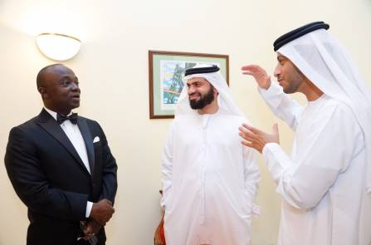 | 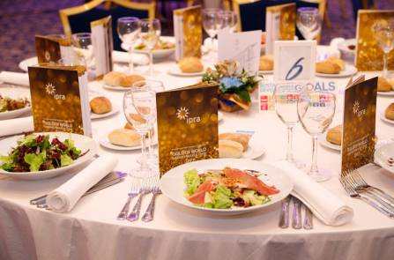 | 

5. Entry Template
You can use this to prepare your entries off line.
Then copy and paste when you go online.

Entry title
GWA Category
1. Summary (100 words)
- Why is the programme worthy of an award?
2. Problem or Opportunity (200 words)
- Organisation for which the programme was conducted.
- Problem or opportunity addressed.
- Geographical area of the programme.
- Measurable objective by which success is evaluated (summary).
3. Research (300 words)
- To define the problem or opportunity
- To determine approaches for the programme.
4. Planning (400 words)
- Communications objectives
- Measurable objective by which success is evaluated (detail).
- Target audiences to be reached and actions desired of them.
- PR messages to target audiences.
- Communication tactics used.
- Consultation with management to secure its support.
5. Execution (400 words)
- Implementation of the communications plan.
- Creative solution
- Difficulties encountered and adjustments made during implementation.
6. Outcomes and Evaluation (400 words)
- Identification, analysis and quantification of results.
- Tangible results which achieved the measurable objectives.

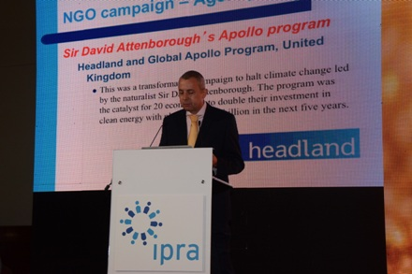 | 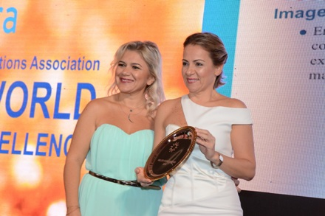 | 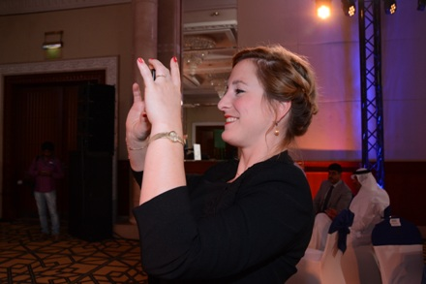

6. GWA Categories
For the 37 categories Agency and In-house are judged separately with separate awards.
Agencies may not submit In-house entries unless they relate to the agency itself.

- Arts and entertainment
For a PR campaign in arts or entertainment.

- Business-to-business
For a business-to-business PR campaign.

- Communication research
For research conducted for the development of business or communication strategies.

- Community engagement
For a PR campaign that helped engage a community in some specific way.

- Community relations
For a community relations campaign.

- Consumer PR for an existing product
For creative PR activities around a consumer product.

- Consumer PR for an existing service
For creative PR activities around a consumer service.

- Corporate communications
For excellence in enhancing a company’s reputation through communications.

- Corporate responsibility
For a PR campaign demonstrating excellence in corporate social responsibility.

- Country, region and city
For a PR campaign to promote a country, a region or a city.

- Crisis management
For excellent communications management during a crisis.

- Crisis communications online
For excellence in the use of social media during a crisis.

- Digital media relations
For a PR campaign showing creativity in its use of social media.

- Environmental
For a PR campaign on an environmental or ecological issue.

- Event management
For the planning and delivery of a successful event with a PR dimension.

- Financial services and investor relations
For use of PR for a financial product or service or in investor relations.

- Food and beverage
For a PR campaign to promote a new or existing food or beverage.

- Gaming and virtual reality
For a PR campaign that launched a development in the gaming or VR industry.

- Healthcare
For a PR campaign in the pharmaceutical or healthcare industry.

- Influencer management
For a PR campaign that made use of identified influencers beyond traditional media.

- Integration of traditional and new media
For the creative integration of traditional and social media in a PR campaign.

- Internal communications
For a creative internal communications campaign that engaged personnel.

- International campaign
For a coordinated PR campaign in more than one country.

- Launch of a new product
For creative PR activities around the launch of a product

- Launch of a new service
For creative PR activities around the launch of a service.

- Media relations
For a PR campaign which showed impressive media reach.

- NGO campaign
For a PR campaign by a charity or non-governmental organisation.

- PR on a shoestring
For a creative PR campaign on a small budget.

- Public affairs
For lobbying that influenced or changed public policy.

- Public sector
For creative use of PR by a public sector body.

- Publications
For a creative PR publication in print or electronic format.

- Reputation and brand management
For the creative positioning of a company image or brand.

- Social media
For a PR campaign demonstrating imaginative use of social media.

- Sponsorship
For a PR campaign that promoted awareness of sponsorship of an event or activity.

- Sport
For a PR campaign to promote a sport for itself or to a community.

- Technology
For a creative PR campaign in the technology sector.

- Travel & tourism
For a PR campaign in the transport, travel, hotel or tourism industries.

7. The Rules
The following are the terms and conditions of entry to the 2018 IPRA GWA. By submitting entries to the competition you assent that you have read and agree to abide by these terms and conditions.

A. Timing and deadlines
Entries open Tuesday 27 February 2018.
Entries close Monday 21 May 2018.

Any entry received after 21 May 2018 is ineligible.

IPRA will acknowledge receipt of each entry.
Entrants going forward to the finals will be contacted in May.

B. Entry Fees
The basic fee is £350 per entry. There is a discount for early-bird entries and a penalty for late entries.

Early (Tuesday 27 February – Monday 26 March 2018) £330
Normal (Tuesday 27 March – Monday 23 April 2018) £360
Late (Tuesday 24 April – Monday 21 May 2018) £400

No refunds are possible for withdrawn entries. All fees must be paid at the time of entry submission preferably via credit card. Payments made direct to IPRA’s bank account must be done within 7 days of submitting the entry with a follow-up confirmation email to IPRA. Only paid entries are eligible for judging and awards.

C. Point of contact
Every entrant must have a designated point of contact: a single person with whom we communicate about the entry plus an alternate backup email. We will send regular email to the point of contact, especially after Finalists are announced. Your organization’s point of contact agrees to:
a) Whitelist (i.e. ensure it does not go to spam) the email address info@ipra.org
b) Read all email promptly and respond as required.

D. Entry submission
Entries must be submitted to IPRA online.

E. Entry summary
In the first stage of judging the jury considers the Entry summary so great care must be taken in its preparation.
Maximum length: 1800 words.
Language: English.

The Summary has 6 parts known as the Criteria:
1. Statement of Merit (100 words)
2. Problem or Opportunity (200 words)
3. Research (300 words)
4. Planning detail (400 words)
5. Execution (400 words)
6. Outcomes and Evaluation (400 words)
See the FAQ for a description of each Criteria.

F. Category
Each entrant chooses a GWA Category or Categories themselves. The Judges reserve the right to change the Category if they believe the new Category is more suited to the Entry. In the event of a dispute as to the Category in which an entry will be judged, the decision of the IPRA staff and GWA Judges will prevail.

G. Supporting material
If your entry is selected as a potential winner you will be notified after May 2017 and asked to supply supporting material as a single PDF file online and additional graphic files. Details of the requirements will be sent at this time and can be found in the FAQ. No entry materials of any kind will be returned.

H. Awards
The Jury’s final choice in each Category will be announced after the judging. The 2017 Grand Prix and the Special Awards will not be revealed until the Gala event. A custom-designed GWA trophy will be presented to all award winners at the Gala event. Award winners may purchase additional trophies directly from the IPRA Secretariat.

I. What if I can’t make it to the Gala: how do I collect my trophy?
Winners who are not at the Gala may purchase their Trophy from IPRA.

J. Publication of winning entries
The Entry Summary of each GWA winning entry may be published on the IPRA website after the final results are announced. This is our way of giving you some additional free exposure. Entrants are advised to not include any confidential or non-public information in their Entry Summaries.

Failure to comply with these Terms & Conditions will make your entries ineligible.

